Module 03 – Production Modeling

Exploratory Data Analysis

*In this section, you should perform some data analysis on the data provided to you. Please format your findings in a visually pleasing way and please be sure to include these cuts:*

* *Make a table of average demand, production capacity, and costs for each quarter, are there differences between quarters?*
* *Since we have temporal data (i.e. year and quarter), see if you can make a yearly and/or quarterly chart showing these metrics over time.*

Model Formulation

*Write the formulation of the model into here prior to implementing it in your Excel model. Be explicit with the definition of the decision variables, objective function, and constraints*

Min: 52.90P1 + 50.61P2 + 48.08P3 + 45.62P4 +1.05(B1 + B2)/2 +1.05(B2 + B3)/2 + 1.05(B3 + B4)/2 + 1.05(B4 +B5)/2

Constraints:

P1 <= 476

P2 <= 485

P3 <= 530

P4 <= 495

28 <= B1 + P1 – 277

70 <= B2+P2 – 705

75 <= B3 +P3 – 751

51 <= B4+P4 - 515

Model Optimized for Cost Reduction

*Implement your formulation into Excel and be sure to make it neat. This section should include:*

* *A screenshot of your optimized final model (formatted nicely, of course)*

*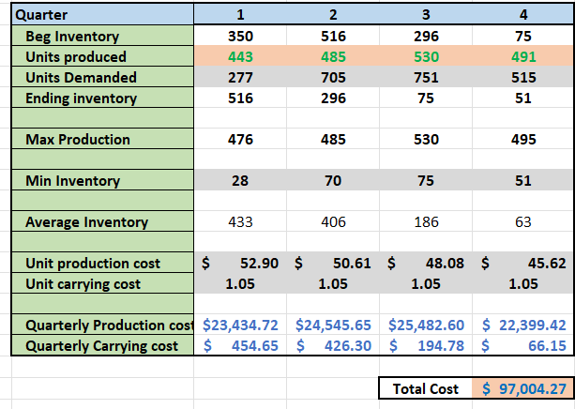*

* *A text explanation of what your model is recommending*
  + My model is recommending that

Model with Stipulation

*Please copy the tab of your original model before continuing with the next part to avoid messing up your original solution. If we remove the production capacity constraint from the model & we removed the carrying cost, what do you think will happen? Try it out and see if it matches your expectation. Try to explain what is happening and talk a bit about fallbacks of models.*

I think that if we remove the carrying cost, it will make it cheaper for us. This is because it will cost us nothing to hold the inventory. As for the capacity constraint, it should also lower because that means that we can hold as much inventory as we want

When I did run the test, it did lower the costs as expected. The production costs, however, increased but the carrying cost was 0. This makes sense because it costs us nothing to hold the inventory.